##### **Assignment_2 (Module 7)**

**Topic : Nmap Live Host Discovery Room Solve With TryHackMe**

**Introduction:**

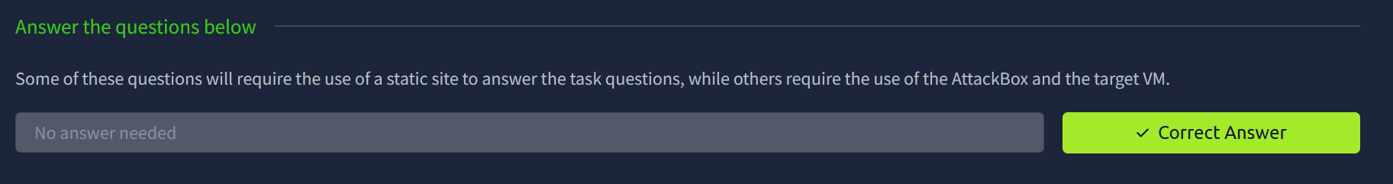

**Subnetworks:**

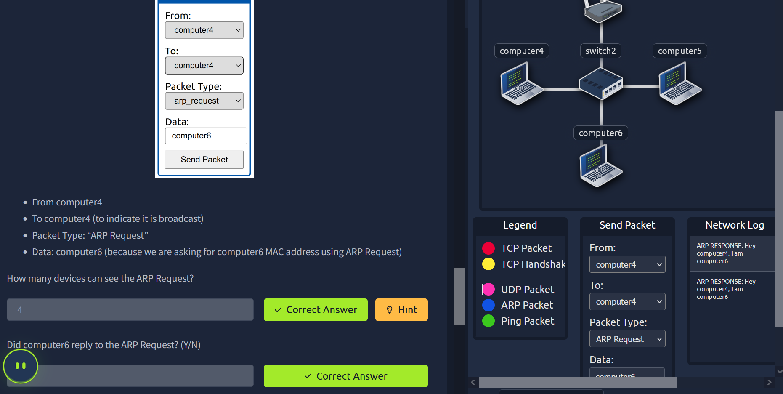

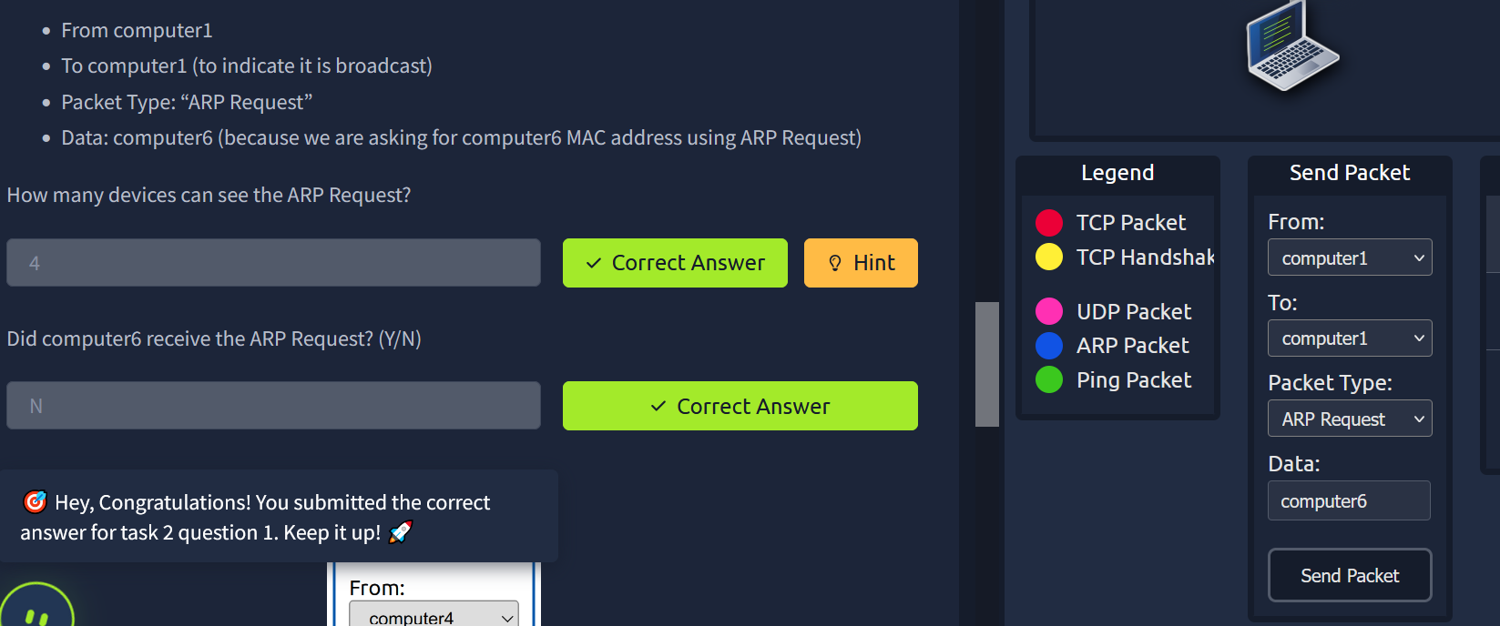

**Enumerating Targets:**

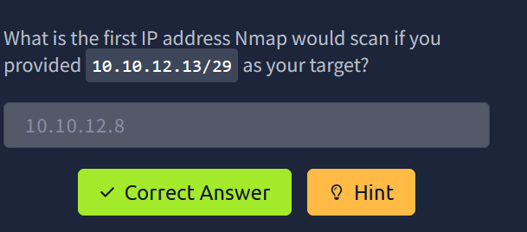

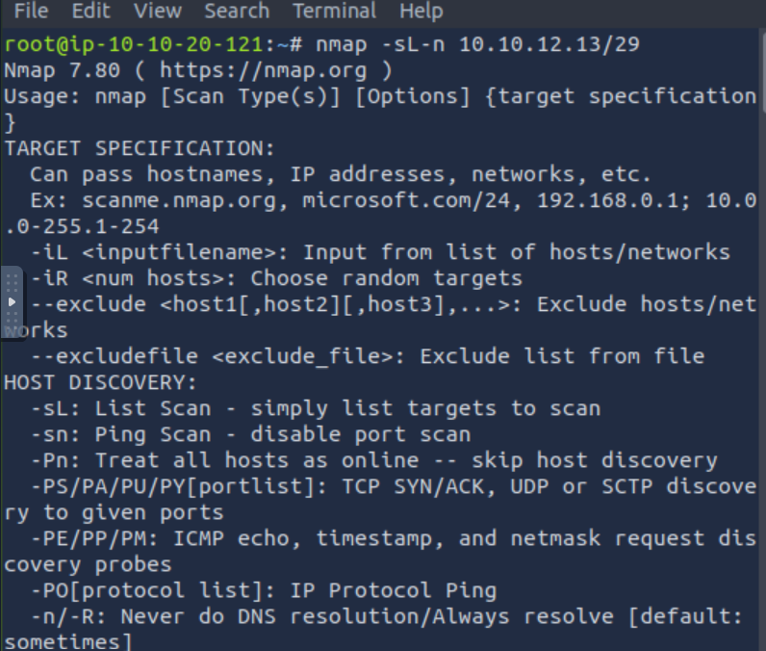

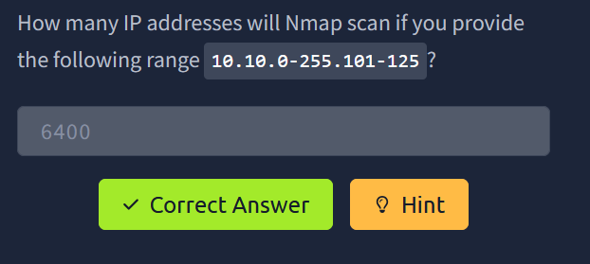

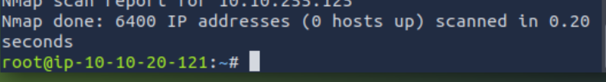

**Discovering Live Hosts:**

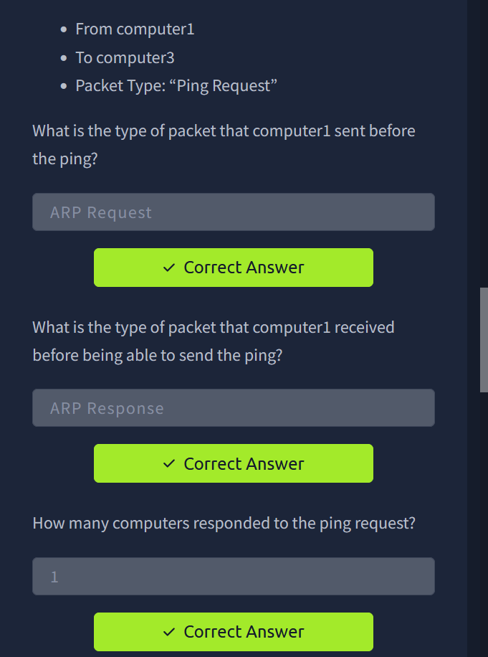

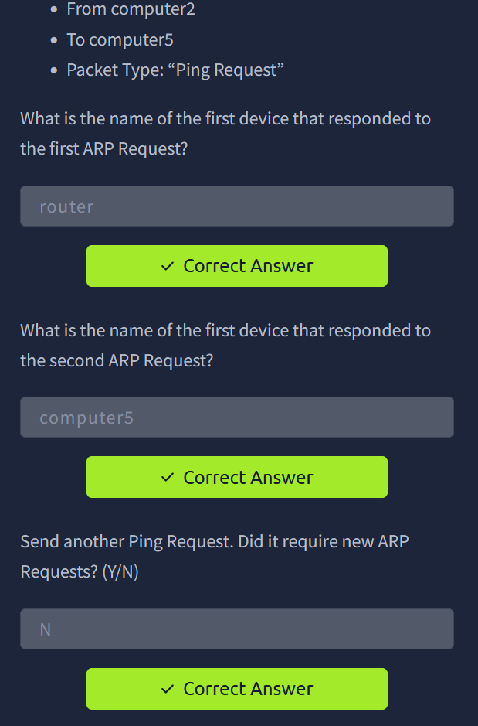

**Nmap Host Discovery Using ARP:**

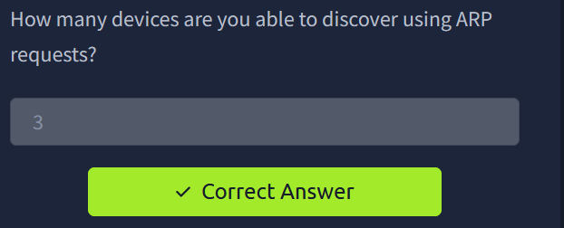

**Nmap Host Discovery Using ICMP:**

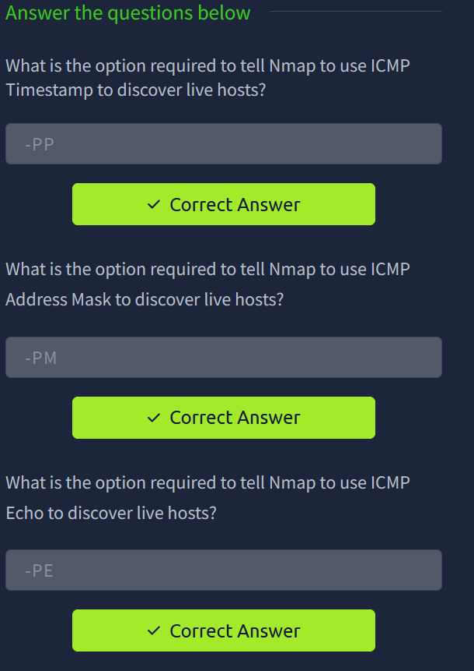

**Nmap Host Discovery Using TCP and UDP:**

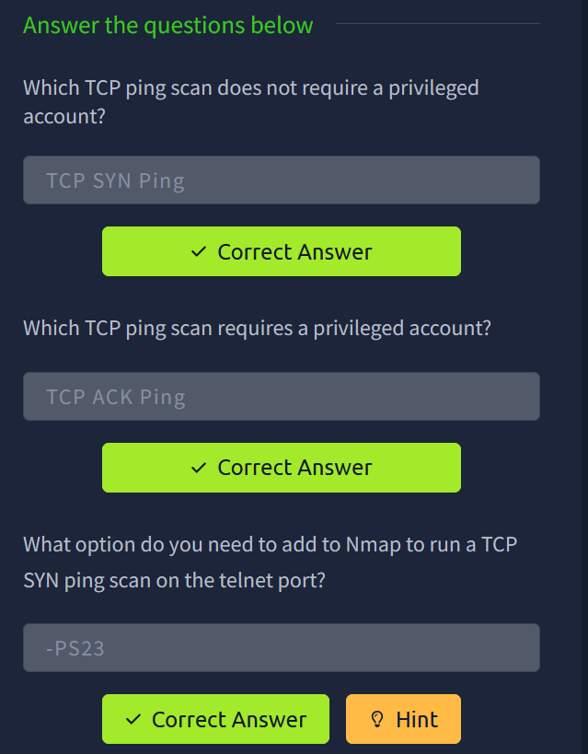

**Using Reverse-DNS Lookup:**

